LoginServlet.java

import java.io.\*;

import java.sql.\*;

import javax.servlet.\*;

import javax.servlet.http.\*;

public class LoginServlet1 extends HttpServlet {

protected void processRequest(HttpServletRequest req, HttpServletResponse res)

throws ServletException, IOException {

res.setContentType("text/html;charset=UTF-8");

PrintWriter p=res.getWriter();

String username = req.getParameter("username");

String password = req.getParameter("password");

boolean validUser = false;

try {

java.lang.Class.forName("com.mysql.cj.jdbc.Driver");

Connection db = DriverManager.getConnection("jdbc:mysql://localhost:3306/userbase", "root", "123456789");

p.println("connected");

String sql="SELECT \* FROM users WHERE username=? AND password=?";

PreparedStatement statement = db.prepareStatement(sql);

statement.setString(1, username);

statement.setString(2, password);

ResultSet r= statement.executeQuery();

if (r.next()) {

validUser = true;

}

}

catch (SQLException|ClassNotFoundException e) {

System.out.print(e);

} if (validUser) {

res.sendRedirect("welcome.jsp");

} else {

//res.sendRedirect("login.jsp");

req.setAttribute("errorMessage", "Invalid User or Password");

req.getRequestDispatcher("login.jsp").forward(req, res);

}

}

}

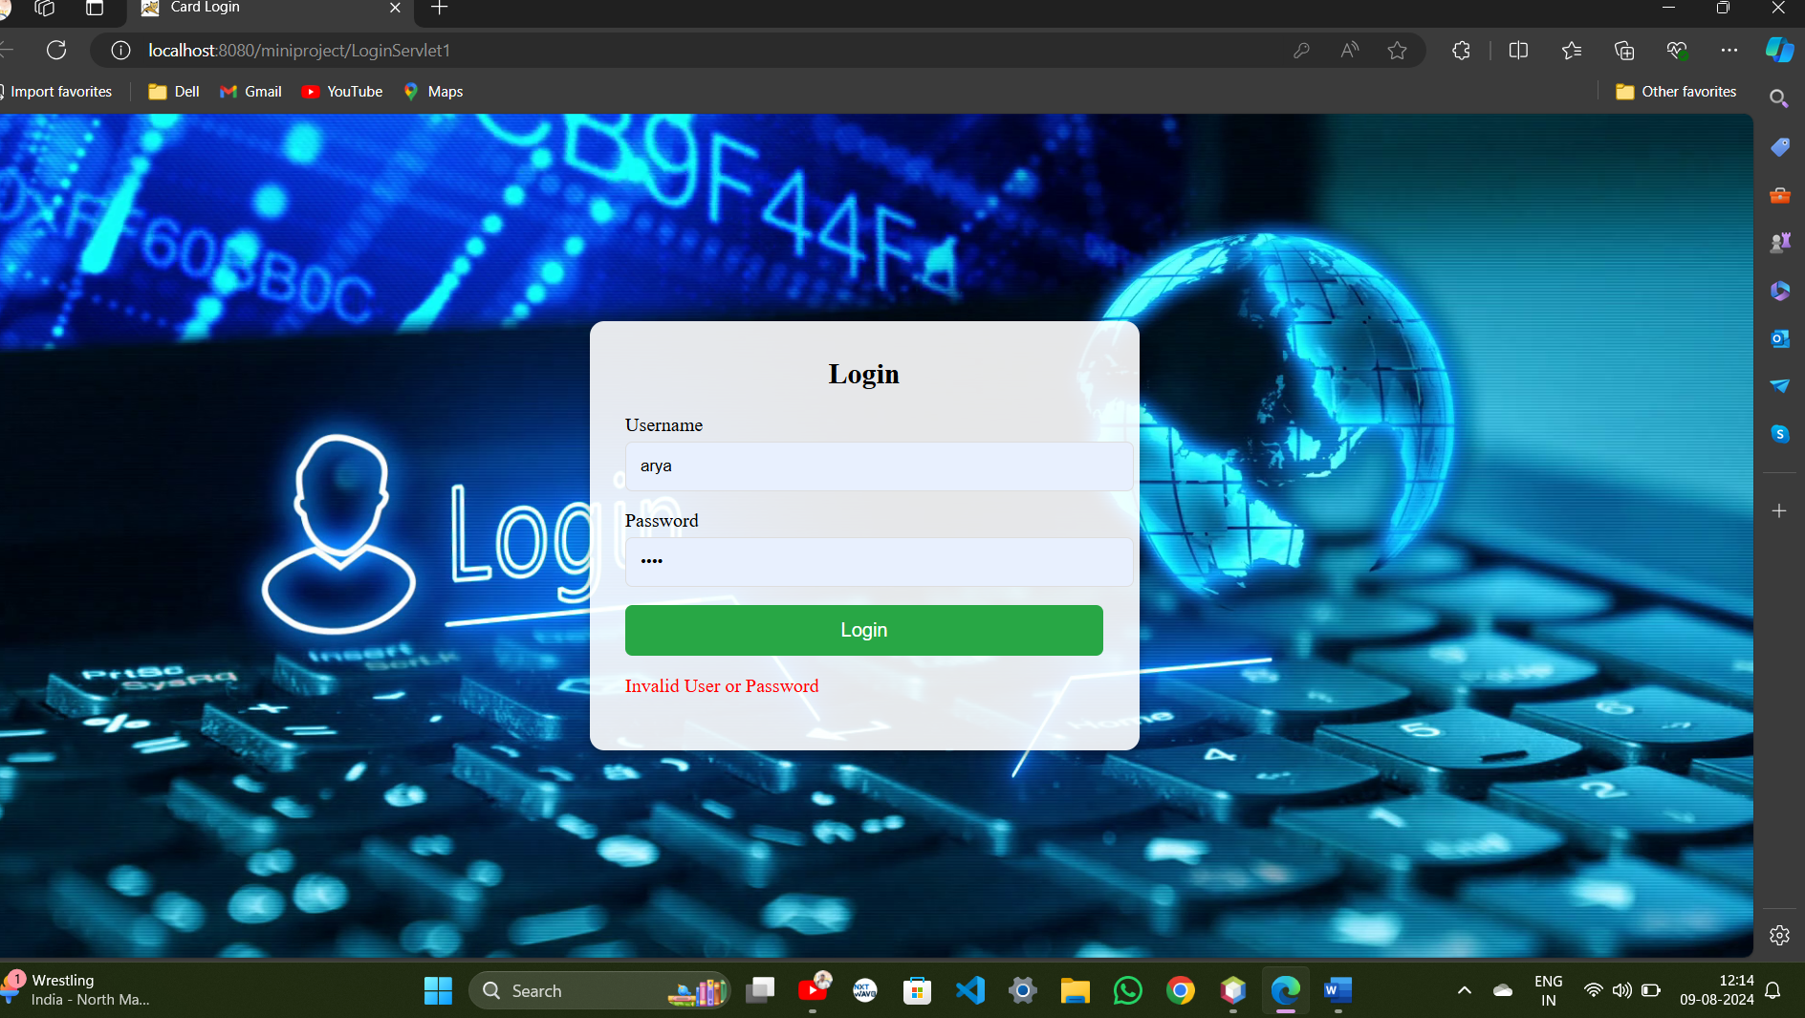

Login.jsp

<!DOCTYPE html>

<html lang="en">

<head>

<meta charset="UTF-8">

<meta name="viewport" content="width=device-width, initial-scale=1.0">

<title>Card Login</title>

<style>

body {

margin: 0;

height: 100vh;

display: flex;

justify-content: center;

align-items: center;

background: url('https://wallpapercave.com/wp/wp6603070.png') ;

background-size: cover;

}

.login-card {

background: rgba(255, 255, 255, 0.9);

padding: 30px;

border-radius: 12px;

box-shadow: 0 4px 8px rgba(0, 0, 0, 0.3);

width: 100%;

max-width: 400px;

}

h2 {

margin: 0 0 20px;

text-align: center;

}

.form-group {

margin-bottom: 15px;

}

.form-group label {

display: block;

margin-bottom: 5px;

}

.form-group input {

width: 100%;

padding: 12px;

border-radius: 6px;

border: 1px solid #ddd;

}

.form-group button {

width: 100%;

padding: 12px;

background-color: #28a745;

border: none;

border-radius: 6px;

color: white;

font-size: 16px;

cursor: pointer;

}

.form-group button:hover {

background-color: #218838;

}

.error-message {

color: red;

margin-bottom: 15px;

}

</style>

</head>

<body>

<div class="login-card">

<h2>Login</h2>

<form action="LoginServlet1" method="post" id="loginForm">

<div class="form-group">

<label for="username">Username</label>

<input type="text" id="username" name="username">

</div>

<div class="form-group">

<label for="password">Password</label>

<input type="password" id="password" name="password">

</div>

<div class="form-group">

<button type="submit">Login</button>

</div>

<script>

document.getElementById('loginForm').addEventListener('submit', function(event) {

alert('Login successful! Welcome back.');

});

</script>

<%

String errorMessage = (String) request.getAttribute("errorMessage");

if (errorMessage != null) {

%>

<p class="error-message"><%= errorMessage %></p>

<%

}

%>

</form>

</div>

</body>

</html>



Welcome.jsp

<%@ page language="java" contentType="text/html; charset=UTF-8" pageEncoding="UTF-8"%>

<!DOCTYPE html>

<html>

<head>

<meta charset="UTF-8">

<meta name="viewport" content="width=device-width, initial-scale=1">

<title>Home - Spring Security</title>

<style>

body {

font-family: Arial, Helvetica, sans-serif;

margin: 0;

background: url("https://www.technocrazed.com/wp-content/uploads/2015/12/Home-Wallpaper-22.jpg") ;

}

.header {

padding: 1px;

text-align: center;

background: #1abc9c;

color: white;

font-size: 30px;

}

.content {

padding: 5px;

}

.menu {

background-color: white;

overflow: hidden;

width: 1000px;

}

.menu a {

float: left;

display: block;

color: black;

text-align: center;

padding: 14px 20px;

text-decoration: none;

}

.menu a:hover {

background-color: #ddd;

color: black;

}

.menu a.active {

background-color: #4CAF50;

color: white;

}

</style>

</head>

<body>

<div class="header">

<h1>College Portal</h1>

<p>Welcome to college Registration page!</p>

</div>

<div class="content">

<h2>Home</h2>

<div class="menu">

<a href="welcome.jsp" class="active">Home</a>

<a href="teacher.jsp">Teacher Register</a>

<a href="register.jsp"> Student Register</a>

</div>

</div>

</body>

</html>

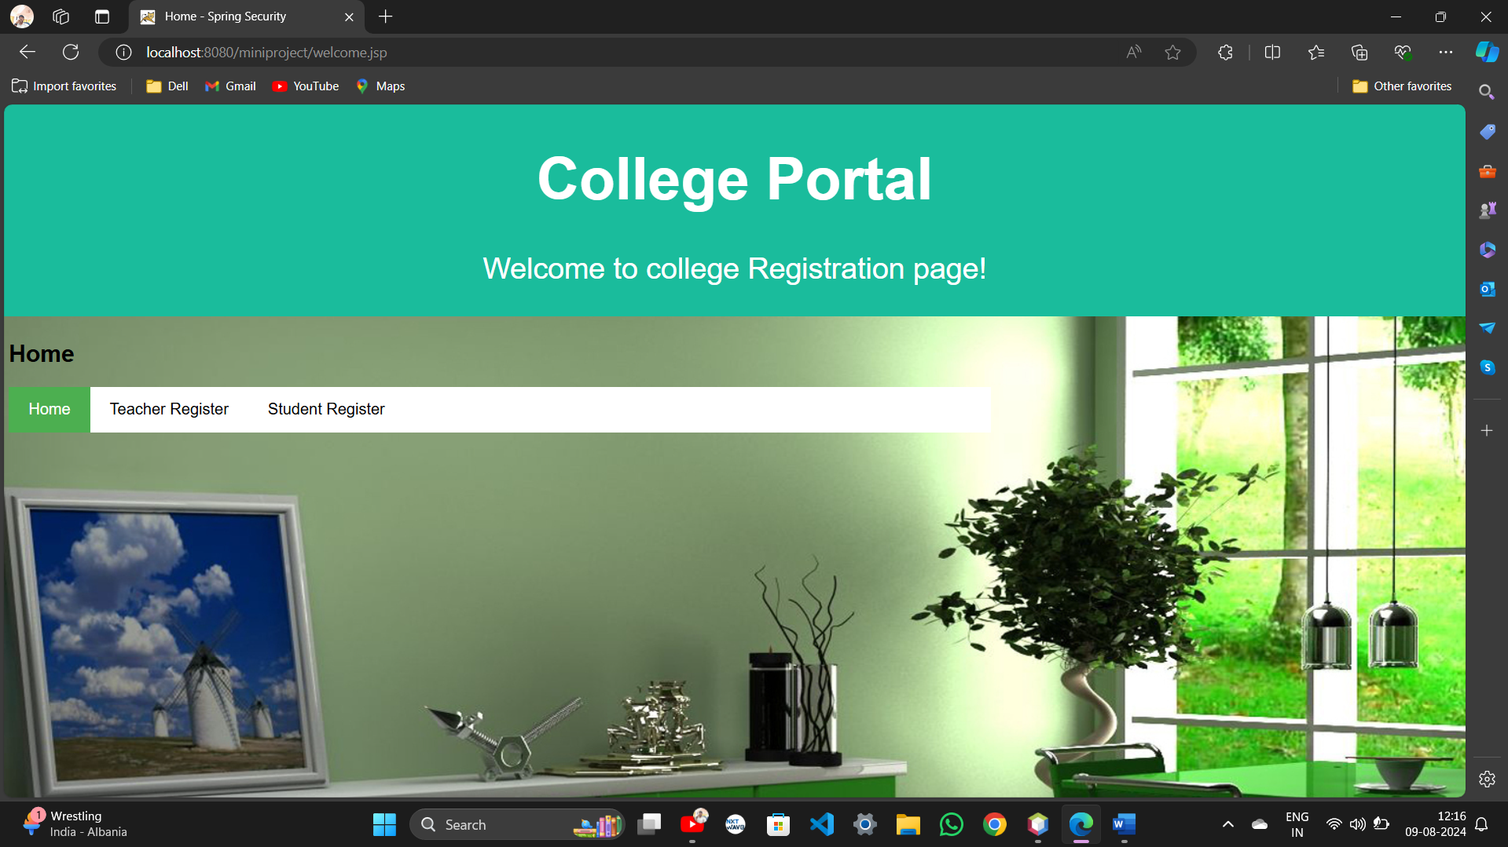

Register.jsp

<%@ page language="java" contentType="text/html; charset=UTF-8" pageEncoding="UTF-8"%>

<!DOCTYPE html>

<html>

<head>

<meta charset="UTF-8">

<title>Student Registration Form</title>

<style>

body {

font-family: Arial, sans-serif;

background-color: #f4f4f4;

margin: 0;

padding: 0;

background: url("https://toplinemanagement.com/wp-content/uploads/2017/01/top-line-management-login-background-1.jpg") ;

}

.container {

width: 50%;

margin: 0 auto;

padding: 20px;

background-color: #fff;

box-shadow: 0 0 10px rgba(0, 0, 0, 0.1);

border-radius: 8px;

margin-top: 50px;

background-color: gainsboro;

}

h1 {

text-align: center;

color: #333;

}

.form-group {

margin-bottom: 15px;

}

label {

display: block;

margin-bottom: 5px;

font-weight: bold;

}

input[type="text"],

input[type="email"],

input[type="tel"],

textarea,

select {

width: 100%;

padding: 8px;

border: 1px solid #ddd;

border-radius: 4px;

box-sizing: border-box;

}

textarea {

resize: vertical;

}

button {

background-color: #4CAF50;

color: #fff;

border: none;

padding: 10px 15px;

text-align: center;

text-decoration: none;

display: inline-block;

font-size: 16px;

margin: 10px 0;

cursor: pointer;

border-radius: 4px;

}

button:hover {

background-color: #45a049;

}

v

</style>

</head>

<body>

<div class="container">

<h1>Student Registration Form</h1>

<form action="Registers" method="post" id="registerForm">

<div class="form-group">

<label for="firstName">First Name:</label>

<input type="text" id="firstName" name="firstName" required>

</div>

<div class="form-group">

<label for="lastName">Last Name:</label>

<input type="text" id="lastName" name="lastName" required>

</div>

<div class="form-group">

<label for="email">Email:</label>

<input type="email" id="email" name="email" required>

</div>

<div class="form-group">

<label for="phone">Phone Number:</label>

<input type="tel" id="phone" name="phone" required>

</div>

<div class="form-group">

<label for="gender">Gender:</label>

<select id="gender" name="gender" required>

<option value="male">Male</option>

<option value="female">Female</option>

<option value="other">Other</option>

</select>

</div>

<div class="form-group">

<label for="course">Course:</label>

<input type="text" id="course" name="course" required>

</div>

<div class="form-group">

<label for="address">Address:</label>

<textarea id="address" name="address" rows="4" required></textarea>

</div>

<button type="submit">Register</button>

<script>

document.getElementById('registerForm').addEventListener('submit', function(event) {

alert('Registration successful!!!');

});

</script>

</form>

</div>

</body>

</html>

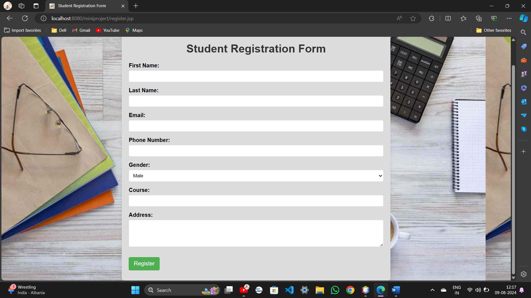

Register.java

import java.io.IOException;

import java.io.PrintWriter;

import javax.servlet.ServletException;

import javax.servlet.http.HttpServlet;

import javax.servlet.http.HttpServletRequest;

import javax.servlet.http.HttpServletResponse;

public class Registers extends HttpServlet {

protected void processRequest(HttpServletRequest request, HttpServletResponse response)

throws ServletException, IOException {

PrintWriter p=response.getWriter();

response.setContentType("text/html;charset=UTF-8");

String firstName = request.getParameter("firstName");

String lastName = request.getParameter("lastName");

String email = request.getParameter("email");

String phone = request.getParameter("phone");

String gender = request.getParameter("gender");

String course = request.getParameter("course");

String address = request.getParameter("address");

p.println("First Name: " + firstName+"<br>");

p.println("Last Name: " + lastName+"<br>");

p.println("Email: " + email+"<br>");

p.println("Phone: " + phone+"<br>");

p.println("Gender: " + gender+"<br>");

p.println("Course: " + course+"<br>");

p.println("Address: " + address+"<br>");

p.println("<div> <button>ok</button></div>");

response.sendRedirect("registerconform.jsp");

}

}

Registerconform.jsp

<!DOCTYPE html>

<html>

<head>

<meta charset="UTF-8">

<title>Registration Confirmation</title>

<link rel="stylesheet" type="text/css" href="styles.css">

<style>

body {

font-family: Arial, sans-serif;

background-color: #f4f4f4;

margin: 0;

padding: 0;

background-image: url("https://thumbs.dreamstime.com/z/registration-online-membership-network-internet-business-technology-concept-104512007.jpg");

}

.container {

width: 40%;

margin: 0 auto;

padding: 20px;

background-color: #fff;

box-shadow: 0 0 10px rgba(0, 0, 0, 0.1);

border-radius: 30px;

margin-top: 50px;

background-color:lightcyan;

align-content: center;

text-align: center;

width: 510px;

}

.p{

color: green;

}

.menu {

background-color: white;

overflow: hidden;

width: 500px;

background-color:yellow;

}

.menu a {

float: left;

display: block;

color: black;

text-align: center;

padding: 14px 20px;

text-decoration: none;

}

.menu a:hover {

background-color: #ddd;

color: black;

}

.menu a.active {

background-color: #4CAF50;

color: white;

}

</style>

</head>

<body>

<div class="container">

<h1>Registration Successful</h1>

<p class="p">Thank you for registering. Your details have been successfully submitted.</p>

<div class="menu">

<a href="welcome.jsp">Back to Home</a>

<a href="register.jsp">Back to Registration Form</a>

<a href="Register">Show details</a>

</div>

</div>

</body>

</html>

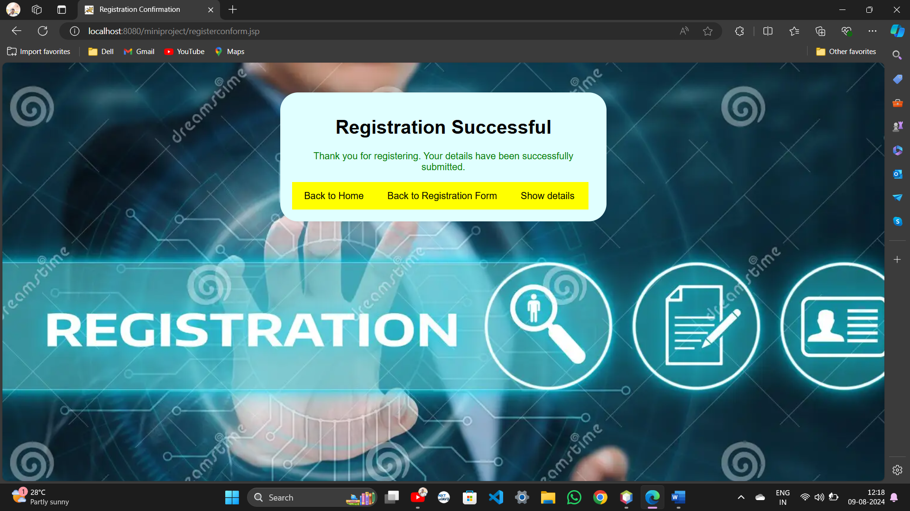

Teacher.jsp

<%@ page language="java" contentType="text/html; charset=UTF-8" pageEncoding="UTF-8"%>

<!DOCTYPE html>

<html>

<head>

<meta charset="UTF-8">

<title>Student Registration Form</title>

<style>

body {

font-family: Arial, sans-serif;

background-color: #f4f4f4;

margin: 0;

padding: 0;

background: url("https://www.technocrazed.com/wp-content/uploads/2015/12/Home-Wallpaper-22.jpg") ;

}

.container {

width: 50%;

margin: 0 auto;

padding: 20px;

background-color: #fff;

box-shadow: 0 0 10px rgba(0, 0, 0, 0.1);

border-radius: 8px;

margin-top: 50px;

background-color: lightgreen;

}

h1 {

text-align: center;

color: #333;

}

.form-group {

margin-bottom: 15px;

}

label {

display: block;

margin-bottom: 5px;

font-weight: bold;

}

input[type="text"],

input[type="email"],

input[type="tel"],

textarea,

select {

width: 100%;

padding: 8px;

border: 1px solid #ddd;

border-radius: 4px;

box-sizing: border-box;

}

textarea {

resize: vertical;

}

button {

background-color: #4CAF50;

color: #fff;

border: none;

padding: 10px 15px;

text-align: center;

text-decoration: none;

display: inline-block;

font-size: 16px;

margin: 10px 0;

cursor: pointer;

border-radius: 4px;

}

button:hover {

background-color: #45a049;

}

v

</style>

</head>

<body>

<div class="container">

<h1>Teacher Registration Form</h1>

<form action="Teacher" method="post" id="registerForm">

<div class="form-group">

<label for="firstName">First Name:</label>

<input type="text" id="firstName" name="firstName" required>

</div>

<div class="form-group">

<label for="lastName">Last Name:</label>

<input type="text" id="lastName" name="lastName" required>

</div>

<div class="form-group">

<label for="email">Email:</label>

<input type="email" id="email" name="email" required>

</div>

<div class="form-group">

<label for="phone">Phone Number:</label>

<input type="tel" id="phone" name="phone" required>

</div>

<div class="form-group">

<label for="gender">Gender:</label>

<select id="gender" name="gender" required>

<option value="male">Male</option>

<option value="female">Female</option>

<option value="other">Other</option>

</select>

</div>

<div class="form-group">

<label for="course"> Enter your Teaching Course:</label>

<input type="text" id="course" name="course" required>

</div>

<div class="form-group">

<label for="address">Address:</label>

<textarea id="address" name="address" rows="4" required></textarea>

</div>

<button type="submit">Register</button>

<script>

document.getElementById('registerForm').addEventListener('submit', function(event) {

alert('Registration successful!!!');

});

</script>

</form>

</div>

</body>

</html>

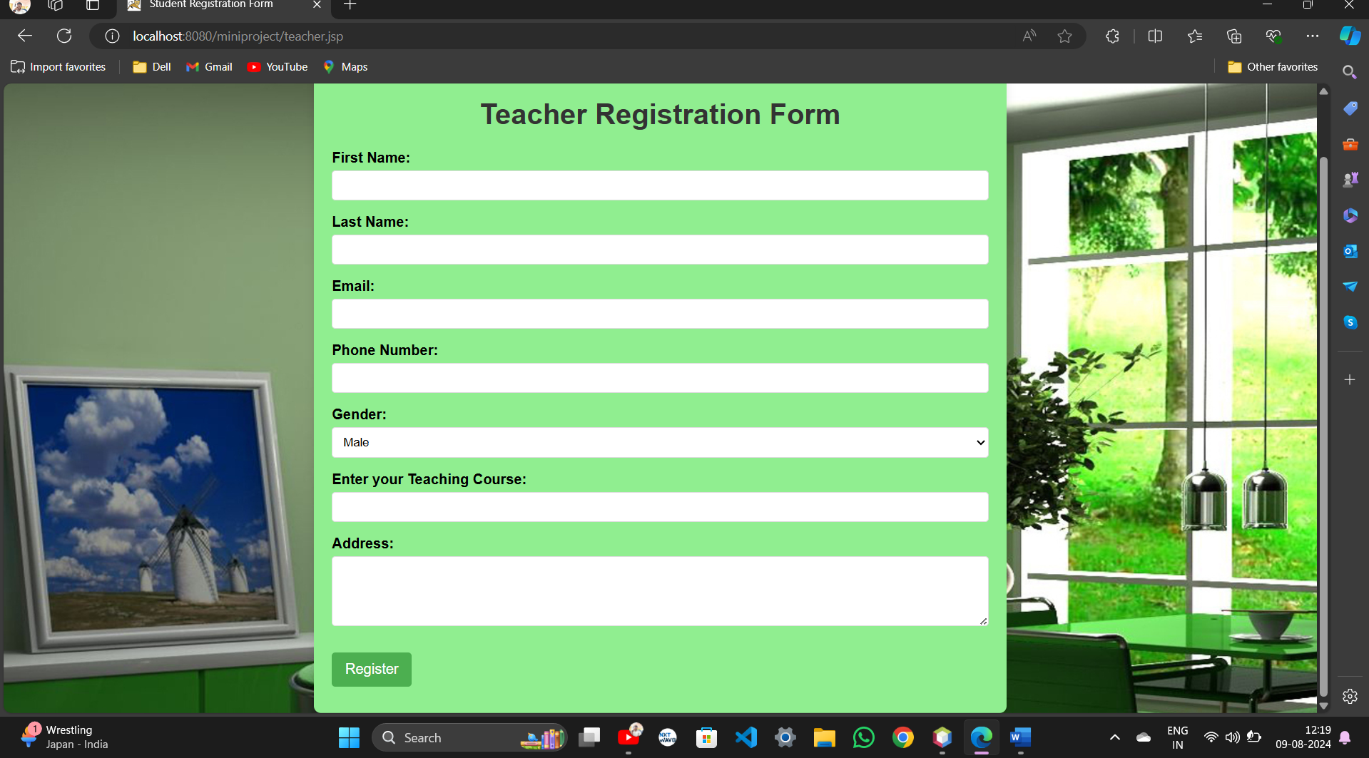

Teacher.java

import java.io.IOException;

import java.io.PrintWriter;

import javax.servlet.ServletException;

import javax.servlet.http.HttpServlet;

import javax.servlet.http.HttpServletRequest;

import javax.servlet.http.HttpServletResponse;

public class Teacher extends HttpServlet {

protected void processRequest(HttpServletRequest request, HttpServletResponse response)

throws ServletException, IOException {

PrintWriter p=response.getWriter();

response.setContentType("text/html;charset=UTF-8");

String firstName = request.getParameter("firstName");

String lastName = request.getParameter("lastName");

String email = request.getParameter("email");

String phone = request.getParameter("phone");

String gender = request.getParameter("gender");

String course = request.getParameter("course");

String address = request.getParameter("address");

p.println("First Name: " + firstName+"<br>");

p.println("Last Name: " + lastName+"<br>");

p.println("Email: " + email+"<br>");

p.println("Phone: " + phone+"<br>");

p.println("Gender: " + gender+"<br>");

p.println("Course: " + course+"<br>");

p.println("Address: " + address+"<br>");

p.println("<div> <button>ok</button></div>");

response.sendRedirect("registerconform.jsp");

}

}